Introduction

The online voting system will process all the information regarding elections, results, voting, and voters. A lot of information is supposed to be handled, which practically seems impossible if done manually.The objective of the system is a replacement of the traditional system that is in existence. This smart system reduces the time for voting and also the system is reliable, and faster.
The existing manual Voting system consumes more time for Vote Casting. Voter has to wait for vote polling station to vote for a right candidate. The Admn has to be check the voter , this voter can vote . then chek voterID present in voters list of booth those are information will be
present then the voter can vote.

Objective
To provide a bug-free application to the admin as well as the user.

The main objective is to build a secured, robust Online Voting System Project where the voting is managed properly.

It maintains the record of the user, and election detail efficiently so that it would be easy to access at any time 24*7.

Abstract
The project “Online Voting System” aims at making the voting process easy in any type of elections. Presently voting is performed using ballot paper and the counting is done manually, hence it consumes a lot of time. There can be possibility of invalid votes. All these make election a tedious task. In recent times in India, due to elections the second wave of COVID transmission also made huge loss of human lives. In our proposed system voting and counting is done with the help of computer in Online. It saves time, avoid error in counting and there will be no invalid votes. It makes the election process easy. It also avoids the process of physical touching or visiting any places and so in the time of pandemic too it will be more helpful to conduct elections. The system deals with the online voting and its details. Allows the user to vote for the candidate online. Can get the details of the candidate and voter as well. Without the wastage of time the citizen can vote the respective candidate. In present existing system we are using ballot paper and counting the number of votes, it takes the lot of time to for the existing process, to overcome the drawbacks in the existing system this particular system was proposed to mark our work much easier and to reduce wastage of time. And more over we doesn’t gets the accurate results in the present existing system. So there is a need for Online Voting Systems.

Hardware & Software Requirement:

Hardware Interfaces
Minimum Hardware requirement
- Processor: i3 or i5
- RAM:4 GB or Higher
- Monitor
- Mouse
- Hard disk: 80 GB

Software Interfaces
- Minimum Software requirement
- Java (Spring Boot, Hibernate)
- Apache Tomcat Server

All these types of software automatic configure inside operating system after installation it having Java, MYSQL, Apache and operating system base configuration file, it doesn’t need to configure manually.

Features and Functionalities

There are Two main users of this application one is the Admin, the admin here can be the administrator, the other is the User.
1) Admin (Administrator)
- Admin can VIEW Users.
- Admin can Update/Delete/Search Users.
- Admin can View Voting List.
- Admin can VIEW User profile.
- Can Log in/Log out of the system
2) User
- User can Do Vote..
- Can Log in/Log out of the system

Chapter-2
System Analysis
Level-0

Level-1

Level-2(Admin Flow)
Level-2(User Flow)

Data Flow Diagram :
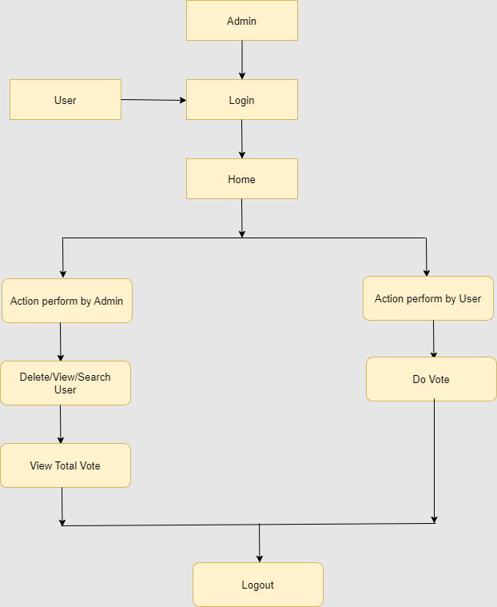

Use Case Diagram :
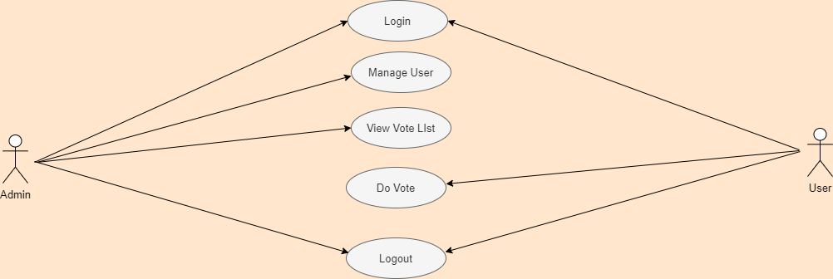

ER Diagram :
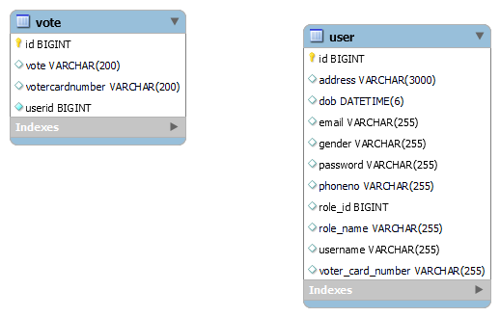

Feasibility:
This project will be developed on computer, so first check whether the technology is technically available or not. Now a day’s computer interaction with any job becomes common for any kind of job or work.

And because of increasing usage of Computer, Computer is also available with a variety of hardware. Vendors can fulfill any type of hardware requirement. The whole project is developed by some special tools or by using languages and databases, which are also available in a variety.

Preliminary investigation of a system examines the feasibility of a system that is useful to an organization. It is the first phase of system development.

The main objective of this phase is to identify the current deficiencies in the user’s environment and to determine which existing problem are going to be solve in proposed system and also which new function needs to be added in proposed system.

An important outcome of such preliminary investigation is to determine whether the system that will meet all needed requirements.

Thus, three tests are carried out on the system namely operation, technical and economical.

Any project is beneficial if and only satisfies the organization requirement. For any new system setup, it only meets to be communicated and work the other supporting system.

The new system meets all existing operations since it provides right information at a right time to the right user. A Leigh man can easily operate with the system.

Technical Feasibility examines whether the technology needed is available and if it is available then it feasible to carry out all project activities.

The technical needs of a system include:

- The facility to produce outputs in a given time.
- Ability to process large number of transaction at a particular speed.
- Giving response to users under certain conditions.

The technology needed for our system is mainly:

- Latest version of browsers.
- Any operating system.

These technologies are available which helps to carry out the system efficiently.

Economical feasibility of a system examines whether the finance is available for implementing the new system and whether the money spent is recoverable the satisfaction.

The cost involves is in designing and developing a good investment for the organization.

Thus, hardware requirements used for proposed system are very standard. Moreover, by making use of proposed system to carry out the work speedily will increase and also saves the valuable time of an organization.

In the proposed system the finance is highly required for the installation of the software’s which can also be recovered by implementing a better system.
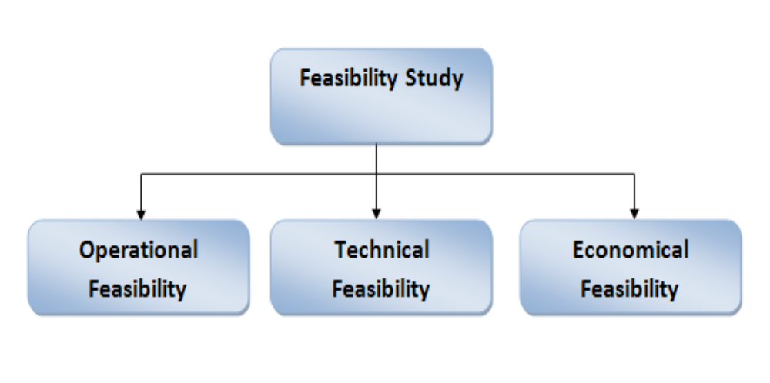

Data dictionary
Data validation:
Procedures are designed to detect errors in data at a lower level of detail. Data validations have been integrated in the system in almost every area where there is a possibility for the user to commit errors. The system will not recognize invalid data.
Whenever an invalid data is keyed in, the system immediately prompts the user and the user has to again key in the data and the system will accept the data only if the data is correct. Validations have been integrated where necessary.
The system is designed to be a user friendly one. In other words the system has been designed to communicate effectively with the user. The system has been designed with pop up menus.

Different Type Of validation:
- Data type validation;
- Range and constraint validation;
- Code and Cross-reference validation; and
Structured validation

Implementation and Testing:
Black-Box Testing:

Black Box Testing, also known as Behavioural Testing, is a software testing method in which the internal structure/ design/ implementation of the item being tested is not known to the tester. These tests can be functional or non-functional, though usually functional.

This can be following way:

- Input interfacing
- Processing
- Output interfacing
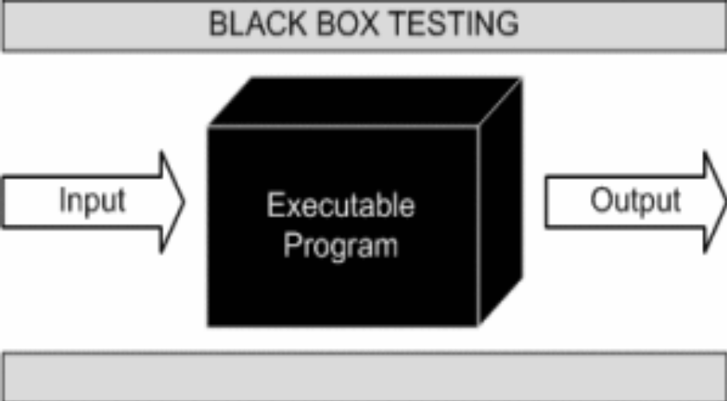

This method is named so because the software program, in the eyes of the tester, is like a black box; inside which one cannot see. This method attempts to find errors in the following categories:

- Incorrect or missing functions

- Interface errors

- Errors in data structures or external database access

- Behaviour or performance errors

- Initialization and termination errors.

White-Box Testing:

White Box Testing ,also known as Clear Box Testing, Open Box Testing, Glass Box Testing, Transparent Box Testing, Code-Based Testing or Structural Testing is a software testing method in which the internal structure/ design/ implementation of the item being tested is known to the tester.

The tester chooses inputs to exercise paths through the code and determines the appropriate outputs. Programming know-how and the implementation knowledge is essential.

White box testing is testing beyond the user interface and into the nitty-gritty of a system.
This method is named so because the software program, in the eyes of the tester, is like a white/ transparent box; inside which one clearly sees.

Limitations and Future Application of the Project

Futures Enhancement:
- In future we can expand this project on the web.
- In future, we can make a display popular courses which has more enrollment.

Screen Snapshot
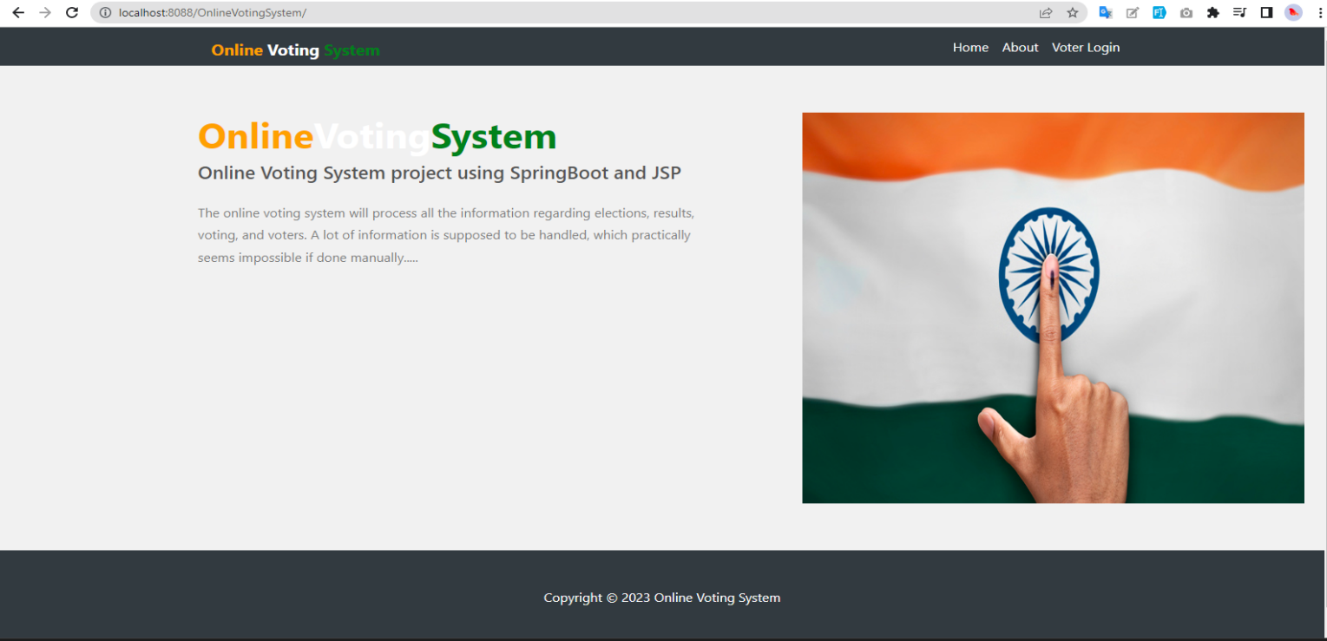
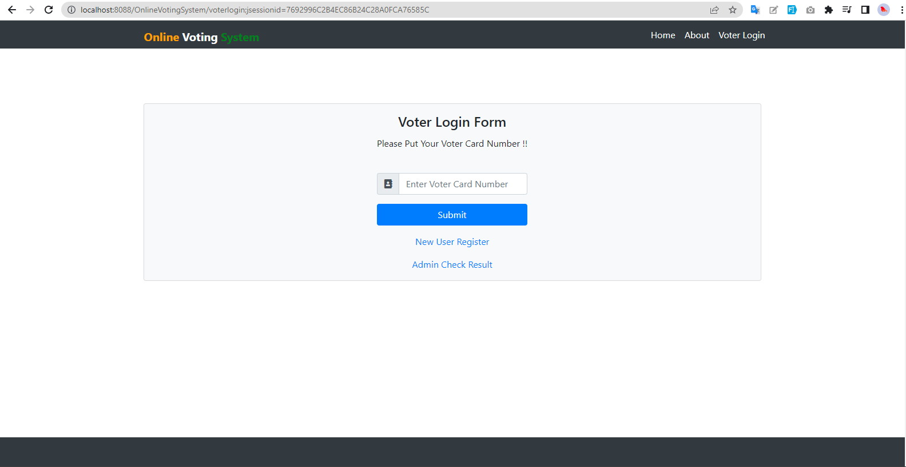
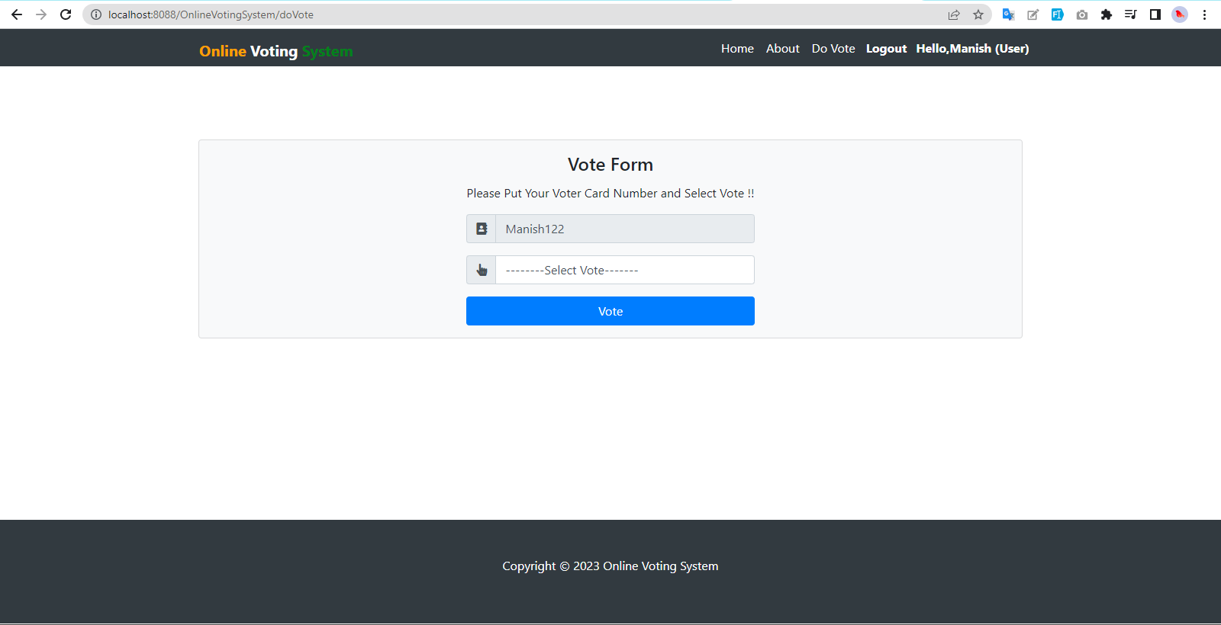
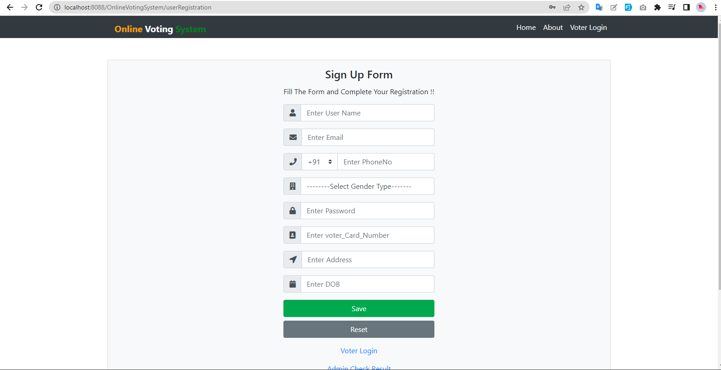

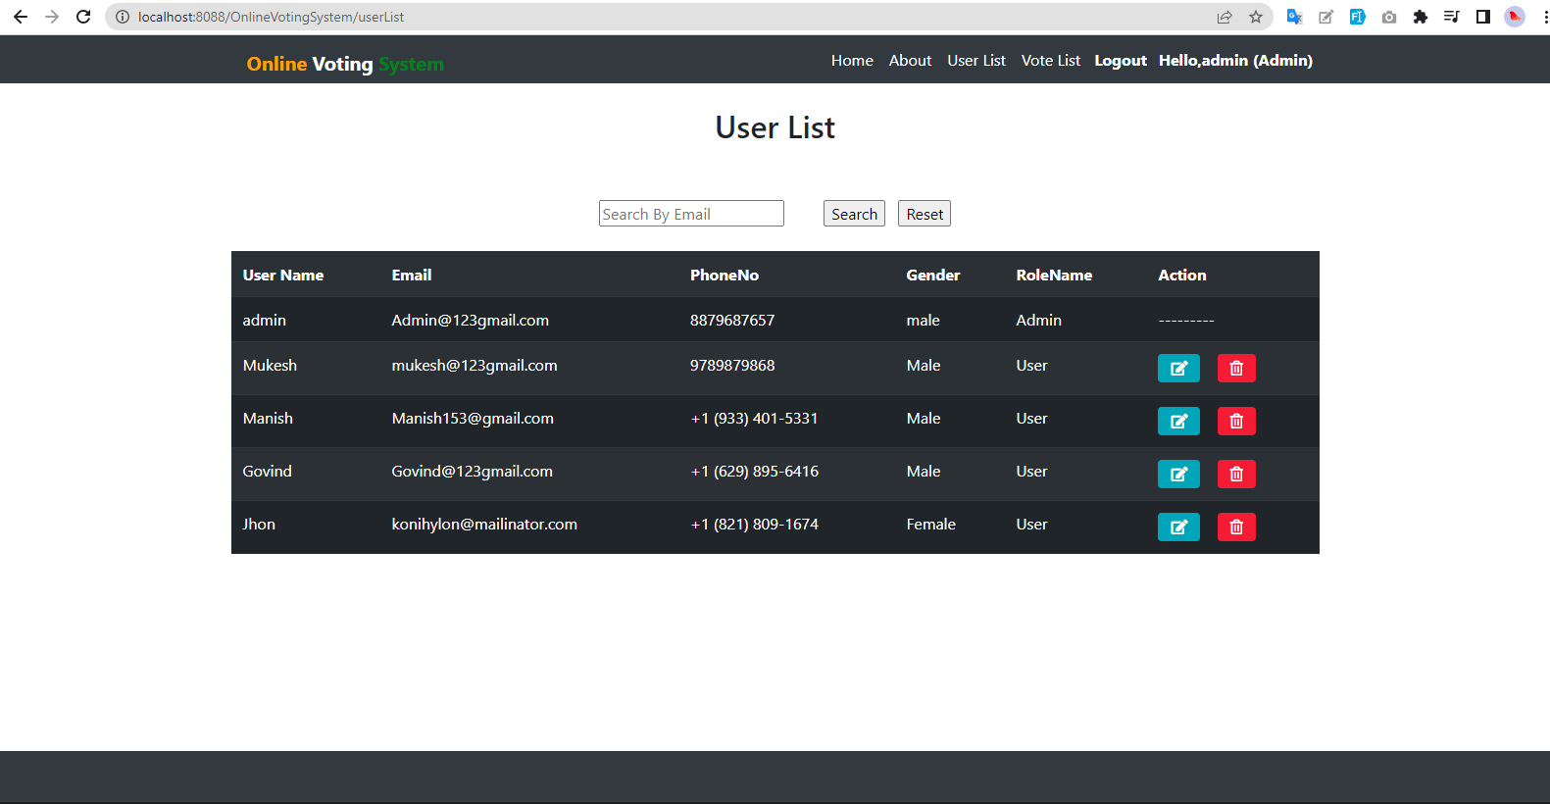
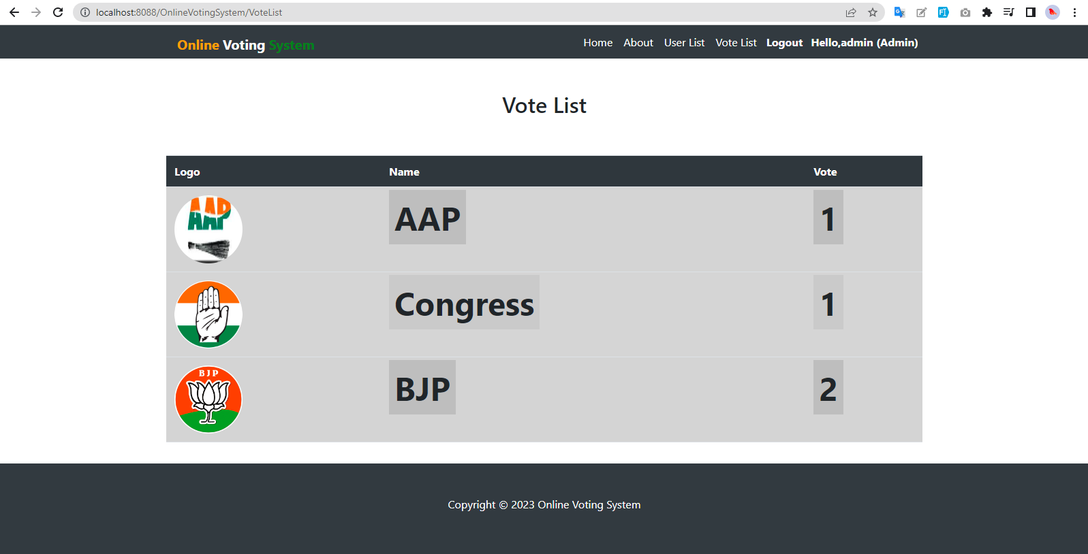

Code
Database Configuration

#server port
server.port=8088

#prefix and suffix configration
spring.mvc.view.prefix=/WEB-INF/layouts/
spring.mvc.view.suffix=.jsp

#Database Configrations
spring.datasource.url=jdbc:mysql://localhost:3306/onlinevotingsystem?createDatabaseIfNotExist=true
spring.datasource.driver-class-name=com.mysql.cj.jdbc.Driver
spring.datasource.username=root
spring.datasource.password=root
spring.jpa.database-platform = org.hibernate.dialect.MySQL8Dialect
spring.jpa.generate-ddl=true
spring.jpa.hibernate.ddl-auto = update
#context Path
server.servlet.context-path=/OnlineVotingSystem
server.servlet.session.timeout=10m
server.servlet.session.cookie.max-age = 1000

Controller:
ppackage com.online.voting.config;

import org.springframework.boot.autoconfigure.EnableAutoConfiguration;
import org.springframework.context.annotation.Bean;
import org.springframework.context.annotation.Configuration;
import org.springframework.web.servlet.ViewResolver;
import org.springframework.web.servlet.config.annotation.EnableWebMvc;
import org.springframework.web.servlet.config.annotation.ResourceHandlerRegistry;
import org.springframework.web.servlet.config.annotation.WebMvcConfigurer;
import org.springframework.web.servlet.view.UrlBasedViewResolver;
import org.springframework.web.servlet.view.tiles3.TilesConfigurer;
import org.springframework.web.servlet.view.tiles3.TilesView;

@Configuration
@EnableWebMvc
@EnableAutoConfiguration
public class OnlineVotingConfig implements WebMvcConfigurer{
@Bean(name = "viewResolver")
public ViewResolver getViewResolver() {
UrlBasedViewResolver viewResolver = new UrlBasedViewResolver();
viewResolver.setViewClass(TilesView.class);
return viewResolver;
}
@Bean(name = "tilesConfigure")
public TilesConfigurer getTilesConfigure() {
TilesConfigurer tilesConfigure = new TilesConfigurer();
tilesConfigure.setDefinitions("/WEB-INF/tiles.xml");
return tilesConfigure;
}

public void addResourceHandlers(ResourceHandlerRegistry registry) {
registry.addResourceHandler("/resources/**").addResourceLocations("/resources/");
}

}

DAO
package com.online.voting.dao;

import java.util.List;

import javax.persistence.EntityManager;
import javax.persistence.NoResultException;

import org.hibernate.Criteria;
import org.hibernate.Session;
import org.hibernate.criterion.Restrictions;
import org.hibernate.query.Query;
import org.springframework.beans.factory.annotation.Autowired;
import org.springframework.stereotype.Repository;

import com.online.voting.dto.UserDTO;

@Repository
public class UserDAOImpl implements UserDAOInt {

@Autowired
public EntityManager entitymanger;

@Override
public long add(UserDTO dto) {
Session session = entitymanger.unwrap(Session.class);
long pk = (long) session.save(dto);
return pk;
}

@Override
public void Update(UserDTO dto) {
Session session = entitymanger.unwrap(Session.class);
session.merge(dto);
}

@Override
public void Delete(long id) {
Session session = (Session) entitymanger.unwrap(Session.class);
Query<UserDTO> query = session.createQuery("delete from UserDTO where id= "+id+"");
query.executeUpdate();
}

@Override
public List<UserDTO> list() {
Session session = entitymanger.unwrap(Session.class);
Query<UserDTO> query = session.createQuery("from UserDTO", UserDTO.class);
List<UserDTO> list = query.getResultList();
return list;
}

@Override
public UserDTO FindByPk(long pk) {
Session session = entitymanger.unwrap(Session.class);
UserDTO dto = session.get(UserDTO.class, pk);
return dto;
}

@Override
public UserDTO FindByEmail(String email) {
Session session = entitymanger.unwrap(Session.class);
Criteria criteria = session.createCriteria(UserDTO.class);
criteria.add(Restrictions.eq("email", email));
UserDTO dto = (UserDTO) criteria.uniqueResult();
return dto;
}

@Override
public UserDTO Authentication(UserDTO dto) {
Session session = entitymanger.unwrap(Session.class);
Query<UserDTO> query = session.createQuery("from UserDTO where email=:email and password=:password", UserDTO.class);
query.setParameter("email",dto.getEmail());
query.setParameter("password",dto.getPassword());
dto = null;
try {
dto = query.getSingleResult();
} catch (NoResultException e) {
}
return dto;
}

@Override
public List<UserDTO> search(UserDTO dto) {
Session session = entitymanger.unwrap(Session.class);
Criteria criteria = session.createCriteria(UserDTO.class);
if (dto != null) {
if (dto.getId()>0) {
criteria.add(Restrictions.eq("id", dto.getId()));
}
if (dto.getEmail() != null && dto.getEmail().length()>0) {
criteria.add(Restrictions.like("email", dto.getEmail() + "%"));
}
}
return criteria.list();
}

@Override
public UserDTO VoterAuthentication(UserDTO dto) {
Session session = entitymanger.unwrap(Session.class);
Query<UserDTO> query = session.createQuery("from UserDTO where votercardnumber=:votercardnumber", UserDTO.class);
query.setParameter("votercardnumber",dto.getVotercardnumber());
dto = null;
try {
dto = query.getSingleResult();
} catch (NoResultException e) {
}
return dto;
}

}

DTO/Entity
package com.online.voting.dto;

import java.util.Date;

import javax.persistence.Column;
import javax.persistence.Entity;
import javax.persistence.Table;

import lombok.Getter;
import lombok.Setter;

@Setter
@Getter
@Entity
@Table(name = "USER")
public class UserDTO extends BaseDTO{

@Column(name = "USERNAME",length = 255)
private String userName;
@Column(name = "EMAIL",length = 255)
private String email;
@Column(name = "PASSWORD",length = 255)
private String password;
@Column(name = "GENDER",length = 255)
private String gender;
@Column(name = "PHONENO",length = 255)
private String phoneNo;
@Column(name = "ROLE_ID",length = 255)
private long roleid;
@Column(name = "ROLE_NAME",length = 255)
private String rolename;
@Column(name = "voter_Card_Number",length = 255)
private String votercardnumber;
@Column(name = "address",length = 3000)
private String address;
@Column(name = "DOB")
private Date dob;

@Override
public String getKey() {
return String.valueOf(id);
}

@Override
public String getValue() {
return userName;
}

}

Services
package com.online.voting.service;

import java.util.List;

import javax.transaction.Transactional;

import org.springframework.beans.factory.annotation.Autowired;
import org.springframework.stereotype.Service;

import com.online.voting.Exception.DuplicateRecordException;
import com.online.voting.dao.UserDAOInt;
import com.online.voting.dto.UserDTO;

@Service
public class UserServiceImpl implements UserServiceInt {

@Autowired
public UserDAOInt dao;

@Override
public long add(UserDTO dto) throws DuplicateRecordException {
UserDTO exisBean = dao.FindByEmail(dto.getEmail());
if (exisBean != null){
throw new DuplicateRecordException("Email Id is Already Exist");
}
long pk = dao.add(dto);
return pk;
}

@Override
@Transactional
public void Update(UserDTO dto) throws DuplicateRecordException {
dao.Update(dto);

}

@Override
@Transactional
public void Delete(long id) {
dao.Delete(id);
}

@Override
public List<UserDTO> list() {
List<UserDTO> list = dao.list();
return list;
}

@Override
public UserDTO FindByPk(long pk) {
UserDTO dto = dao.FindByPk(pk);
return dto;
}

@Override
public UserDTO FindByEmail(String email) {
UserDTO dto = dao.FindByEmail(email);
return dto;
}

@Override
public UserDTO Authentication(UserDTO dto) {
dto = dao.Authentication(dto);
return dto;
}

@Override
public List<UserDTO> search(UserDTO dto) {
List<UserDTO> list = dao.search(dto);
return list;
}

@Override
public UserDTO VoterAuthentication(UserDTO dto) {
dto = dao.VoterAuthentication(dto);
return dto;
}

}

BIBLIOGRAPHY
Online Voting Systems have many advantages over the traditional voting system. Some of these advantages are less cost, faster generation results, easy accessibility, accuracy, and low risk of human and mechanical errors. It is very difficult to develop online voting system which can allow security and privacy on the high level. Future development focused to design a system which can be easy to use and will provide security and privacy of votes on acceptable level by proper authentication and processing section.. It is easy to use and it is less time consuming. It is very easy to debug.
.

